Exercise (Java 8)
- Write the following a functional interface and implement it using lambda:

  - First number is greater than second number or not Parameter (int ,int ) Return boolean
public class Java8 {
public static void main(String[] args) {
GreaterNumberCheck greaterNumberCheck=(a,b)->{
if(a>b)
return true;
else
return false;
};
System.out.println(greaterNumberCheck.isGreater(5,4));
}
}
interface GreaterNumberCheck{
boolean isGreater(int num1,int num2);
}
Output:
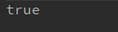

  - Increment the number by 1 and return incremented value Parameter (int) Return int
public class Java8 {
public static void main(String[] args) {
IncrementNumber incrementNumber=a->a+1;
System.out.println(incrementNumber.increment(9));
}
}
interface IncrementNumber{
int increment(int num);
}
Output:
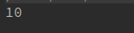

  - Concatination of 2 string Parameter (String , String ) Return (String)

public class Java8 {
public static void main(String[] args) {
//trying in a different way
String result=((StringConacatenate)(string1,string2) ->
string1.concat(string2)
).concatenate("amarjeet","malik");
System.out.println(result);
}
}
interface StringConacatenate{
String concatenate(String string1, String string2);
}
Output:

  - Convert a string to uppercase and return . Parameter (String) Return (String)

public class Java8 {
public static void main(String[] args) {
//trying in a different way
ToUpperCaseCustom toUpperCaseCustom=string1 -> string1.toUpperCase();
System.out.println("Result in uppercase: "+toUpperCaseCustom.toUpperCaseCustom("amarjeet"));
}
}
interface ToUpperCaseCustom{
String toUpperCaseCustom(String string1);
}
Output:

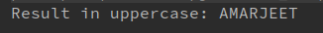

- Create a functional interface whose method takes 2 integers and return one integer.
public class Java8 {
public static void main(String[] args) {
//trying in a different way
Adder adder=(a,b)-> a+b;
System.out.println("Result : "+adder.add(22,18));
}
}
@FunctionalInterface
interface Adder{
int add(int a,int b);
}
Output:
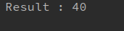

- Using (instance) Method reference create and apply add and subtract method and using (Static) Method reference create and apply multiplication method for the functional interface created.
public class Java8 {
int add(int a,int b){
return a+b;
}
int sub(int a,int b){
return a-b;
}
static int multiply(int a,int b){
return a*b;
}
public static void main(String[] args) {
MethodReferenceExample methodReferenceExample1=new Java8()::add;
MethodReferenceExample methodReferenceExample2=new Java8()::sub;
MethodReferenceExample methodReferenceExample3=Java8::multiply;
System.out.println("Result of Addition : "+methodReferenceExample1.apply(6,4));
System.out.println("Result of Subtraction : "+methodReferenceExample2.apply(6,4));
System.out.println("Result of Multiplication : "+methodReferenceExample3.apply(6,4));
}
}
@FunctionalInterface
interface MethodReferenceExample{
int apply(int a,int b);
}
Output:
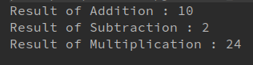

- Create an Employee Class with instance variables (String) name, (Integer)age, (String)city and get the instance of the Class using constructor reference
class Student{
String name;
int age;
String city;
Student(String name, int age, String city) {
this.name = name;
this.age = age;
this.city = city;
System.out.println("name ="+name);
System.out.println("age ="+age);
System.out.println("city ="+city);
}
public static void main(String[] args) {
ConstructorReference constructorReference=Student::new;
constructorReference.printDetails("amarjeet",21,"malik");
}
}
interface ConstructorReference{
Student printDetails(String a, int b, String c);
}

Output:
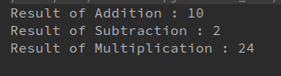

- Implement following functional interfaces from java.util.function using lambdas:
(1) Consumer
(2) Supplier
(3) Predicate
(4) Function
  - Consumer:
import java.util.ArrayList;
import java.util.List;
import java.util.function.Consumer;
class Java8 {
public static void main(String[] args) {
Consumer display=a->System.out.println(a);
display.accept("hello amarjeet");
Consumer<List<Integer>> displayList= list -> list.stream().forEach(a-> System.out.println(a));
//Multiplying list by 2
Consumer<List<Integer>> displayLoop= list -> {
for(int i=0;i<list.size();i++)
list.set(i,list.get(i)*2);
};
List<Integer> list=new ArrayList<>();
list.add(5);
list.add(9);
list.add(7);

displayLoop.accept(list);
//printing list after modification
displayList.accept(list);
}
}
Output:
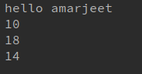

II. Supplier:
import java.util.ArrayList;
import java.util.List;
import java.util.function.Consumer;
import java.util.function.Supplier;
class Java8 {
public static void main(String[] args) {
Supplier<Double> randomValue=() -> Math.random();
System.out.println("printing random value using supplier interface: "+randomValue.get());
}
}
Output:
III). Predicate:
import java.util.function.Predicate;
class Java8 {
public static void main(String[] args) {
//Simple Predicate example
Predicate<Integer> checkIfEven =a -> {
if(a%2==0)
return true;
else
return false;
};
System.out.println("testing even? "+checkIfEven.test(19));

}
}
Output:
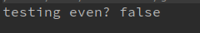

IV) Function:
import java.util.function.Function;
class Java8 {
public static void main(String[] args) {
//Simple Function Interface Example
//it takes one argument and return a value
Function<Integer,Double> makehalf= a -> a / 2.0;
System.out.println(makehalf.apply(14));
}
}
Output:
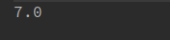

- Create and access default and static method of an interface.
class Java8 implements DefaultAndStatic{
public static void main(String[] args) {
DefaultAndStatic defaultAndStatic=new Java8();
defaultAndStatic.print();
DefaultAndStatic.shared();
}
}
interface DefaultAndStatic{
default void print(){
System.out.println("hi, i am default method of interface");
}
static void shared(){
System.out.println("Static method: Shared among classes that implements me");
}
}
Output:
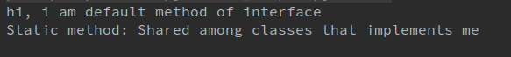
- Override the default method of the interface.
class Java8 implements DefaultAndStatic{
public void print(){
System.out.println("overriding default method");
}

public static void main(String[] args) {
DefaultAndStatic defaultAndStatic=new Java8();
defaultAndStatic.print();
}
}
interface DefaultAndStatic{
default void print(){
System.out.println("hi, i am default method of interface");
}
}
Output:
- Implement multiple inheritance with default method inside interface.
class Java8 implements Derived{
public void print(){
System.out.println("Java8 class");
Derived.super.print();
}
public static void main(String[] args) {
Derived derived=new Java8();
derived.print();
}
}
interface Derived extends Interface1,Interface2{
default void print(){
System.out.println("Derived interface");
Interface1.super.print();
Interface2.super.print();
}
}
interface Interface1 extends Top{
default void print(){
System.out.println("interface1");
}
}
interface Interface2 extends Top{
default void print(){
System.out.println("interface2");
}
}
interface Top{
default void print(){
System.out.println("Top interface");
}
}
Output:
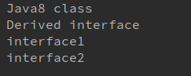

- Collect all the even numbers from an integer list.
import java.util.Arrays;
import java.util.List;
public class Lambda {
public static void main(String[] args) {
List<Integer> list= Arrays.asList(3,6,4,8,11,14,15);
System.out.println("printing even elements from above list:");
list.stream().filter(a -> a%2==0).forEach(System.out::println);
}
}
Output:
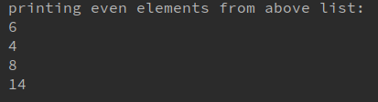

- Sum all the numbers greater than 5 in the integer list.
import java.util.Arrays;
import java.util.List;
import java.util.stream.Collectors;
public class Lambda {
public static void main(String[] args) {
List<Integer> list= Arrays.asList(3,6,4,8,11,14,15);
System.out.print("Sum of all numbers > 5 = ");
System.out.println(
list.stream().filter(a -> a > 5).collect(Collectors.summarizingInt(value -> value)).getSum()
);
}
}
Output:
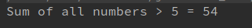

- Find average of the number inside integer list after doubling it.
import java.util.Arrays;
import java.util.List;
import java.util.stream.Collectors;
public class Lambda {
public static void main(String[] args) {
List<Integer> list= Arrays.asList(3,6,4,8,11,14,15);
System.out.print("Average of numbers after getting doubled = ");
System.out.println(
list.stream().collect(Collectors.summarizingInt(value -> value*2)).getAverage()
);
}
}
Output:

- Find the first even number in the integer list which is greater than 3.
import java.util.Arrays;
import java.util.List;
public class Lambda {
public static void main(String[] args) {
List<Integer> list= Arrays.asList(3,6,4,8,11,14,15);
System.out.print("First number in list > 3 = ");
System.out.println(
list.stream().filter(a-> a>3).findFirst().get()
);
}
}
Output:
